

PROPOSAL DOCUMENT

Outlook Exchange Setup

28 September 2019
© Sautech (Pty) Ltd. http://www.sautech.net

INTRODUCTION

The purpose of this document is to provide a complete step-by-step installation manual to configure your online hosted exchange profile. After all procedures in this document is followed completely, you will be able to connect to your new hosted exchange account using Microsoft Office 2007 sp3 and above.

Outlook setup

This procedure will help you configure your Microsoft outlook to be able to connect to the exchange server

- Click on Start -> control panel, once opened , double click the “Mail” icon

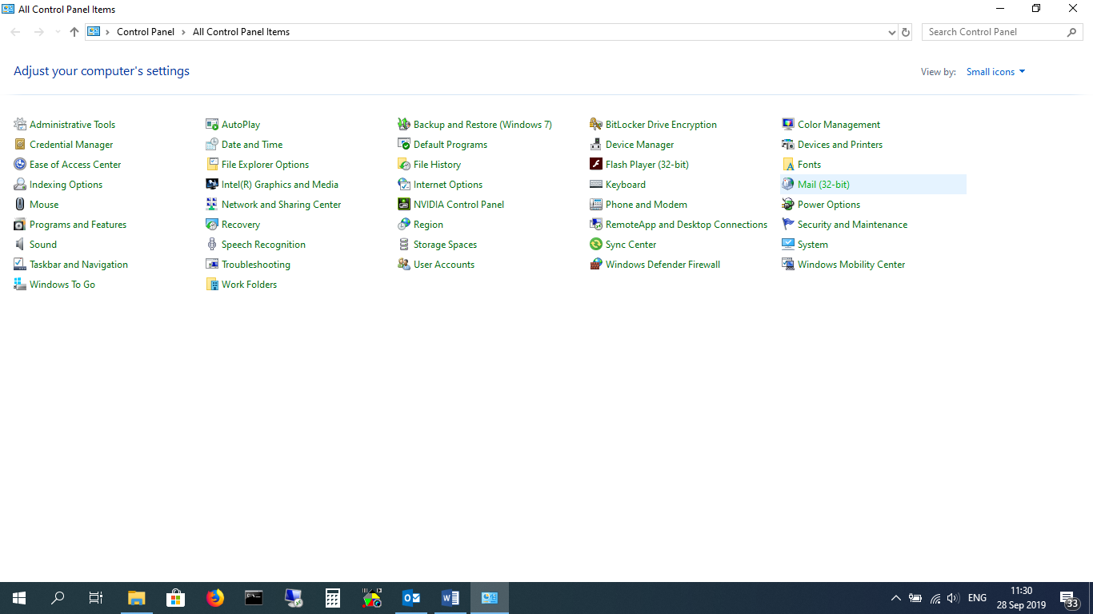

- Click on “Show Profiles”

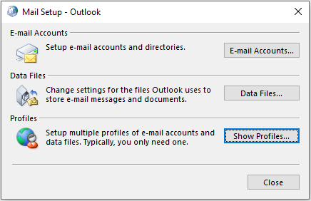

- Click on “Add”

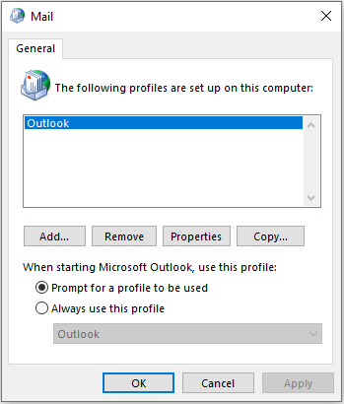

Make sure “prompt for a profile to be used” is selected (When we finish this process, and start outlook, you can select your old email or the newly created Exchange profile”

- Type a name in the profile window “example: New Exchange” and click on “ok”

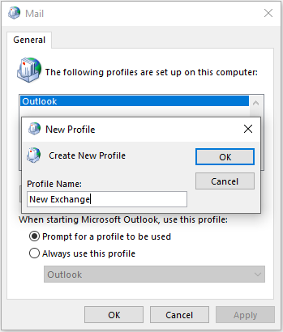

- Type Your Name,
Email Address, and email password x 2 – Click on Next

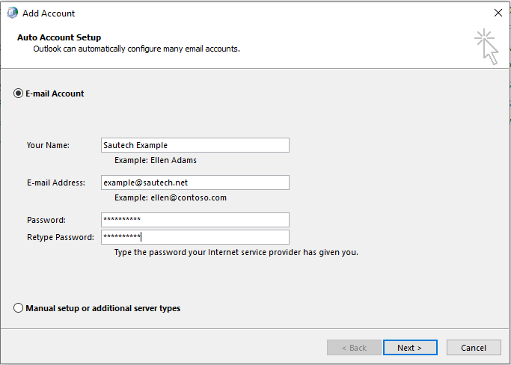

- Outlook will now configure the Mailbox.
Enter email password again and tick the box.

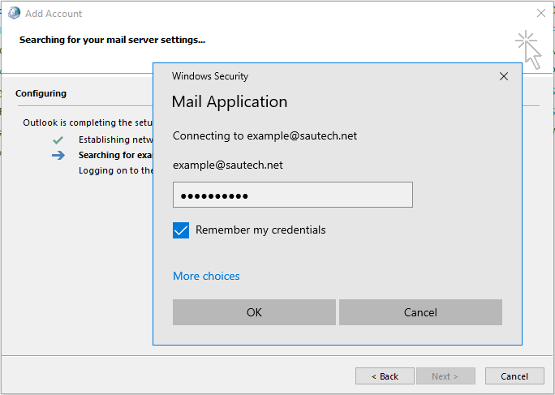

- Mailbox successfully configured.
Click on “Finish”

